EXPT NO:8 | FORECASTING AND PREDICTIVE ANALYTICS USING TABLEAU  AND POWER BI
DATE: 14.08.2026

PRE-LAB QUESTIONS
- What is forecasting in the context of Business Intelligence (BI)?
Forecasting in BI involves analyzing historical data patterns to estimate future business outcomes and metric values. It utilizes statistical algorithms, trend analysis, and seasonal patterns to project upcoming performance metrics like sales revenue. This helps organizations anticipate market shifts, allocate resources efficiently, and make proactive strategic decisions. By identifying underlying patterns in past performance, BI forecasting minimizes operational uncertainty for future planning.

- Explain the difference between predictive analytics and descriptive analytics.
Descriptive analytics focuses on summarizing historical data to explain what has already happened in the past. Predictive analytics uses statistical models and forecasting techniques to project future trends and estimate what will happen next. Descriptive analysis relies on basic aggregation and historical reporting, whereas predictive analysis models future probabilities. Together, descriptive analytics establishes baseline metrics while predictive analytics guides future business strategy.

- Name two common forecasting methods used in Tableau and Power BI.
Exponential Smoothing (ETS) is widely used in Tableau to project time-series trends while incorporating seasonality. Built-in Line Chart Forecasting in Power BI uses Error, Trend, and Seasonal decomposition models to estimate future values. Linear Regression models can also be implemented to identify straight-line directional trends across historic time intervals. Moving Averages are frequently calculated using custom measures or DAX formulas to smooth out short-term fluctuations.

- Why is data granularity important for accurate forecasting?
Data granularity determines the aggregation level—such as daily, weekly, or monthly intervals—used for time-series analysis. Selecting proper granularity ensures subtle temporal trends and recurring seasonal spikes are accurately captured. Excessively broad aggregation can smooth out and erase critical high-frequency demand patterns.

- Name two challenges in forecasting using multiple data sources.
Integrating disparate datasets often results in mismatched date formats, inconsistent schemas, and duplicate order records. Establishing correct relationship cardinalities across distinct tables like sales and promotions requires extensive data cleaning.

IN-LAB EXERCISE:
OBJECTIVE:
To perform time series forecasting and predictive analytics on historical sales data using Tableau and Power BI, and visualize future trends for informed decision-making. PROCEDURE:
- Data Collection:
  - Import historical sales data from multiple sources:
    - Dataset 1: Sales Data (CSV) → Order ID, Order Date, Region, Sales Amount
    - Dataset 2: Promotions Data (Excel) → Promotion ID, Region, Promotion Start Date, Promotion End Date, Discount
- Data Preparation and Transformation:
  - Clean data: standardize date formats, remove duplicates, handle missing values.
  - Aggregate sales data at the required granularity (daily, weekly, or monthly).
  - Ensure numeric fields (Sales, Discount) are correct.
- Data Integration and Modeling:
  - Tableau: Connect datasets and relate them using the Region field.
  - Power BI: Create relationships in the Model view; define cardinality where necessary.
- Forecasting and Predictive Analytics:
  - Tableau:
    - Use the Forecast feature on Sales over time. o Apply trend models like Exponential Smoothing and visualize prediction intervals.
  - Power BI:
    - Use built-in forecasting in line charts. o Optionally, create a DAX measure for predicted sales using moving averages or linear regression.
- Create Calculated Fields:
  - Forecasted Sales = Predicted value from the model
  - Sales Growth % = ((Forecasted Sales – Actual Sales) / Actual Sales) * 100
- Design a Comprehensive Dashboard:
  - Line chart showing actual vs. forecasted sales over time.
  - KPI cards: Total Forecasted Sales, Expected Growth %.
  - Use combo charts to show sales trends along with promotion periods.
  - Highlight regions with expected growth above or below target thresholds.
- Validate Forecast Accuracy:
  - Compare forecasts against actual historical sales (back-testing).
  - Adjust forecasting parameters if necessary (e.g., seasonality length, smoothing factor).
- Publishing and Sharing:
  - Tableau: Publish workbook to Tableau Public or Tableau Server.
  - Power BI: Publish report to Power BI Service and share with stakeholders.
Experiment Datasets:
  - Dataset 1: Historical Sales Data (CSV) → Order ID, Order Date, Region, Sales
  - Dataset 2: Promotions Data (Excel) → Promotion ID, Region, Promotion Start/End Date, Discount
POWER BI DASHBOARD :
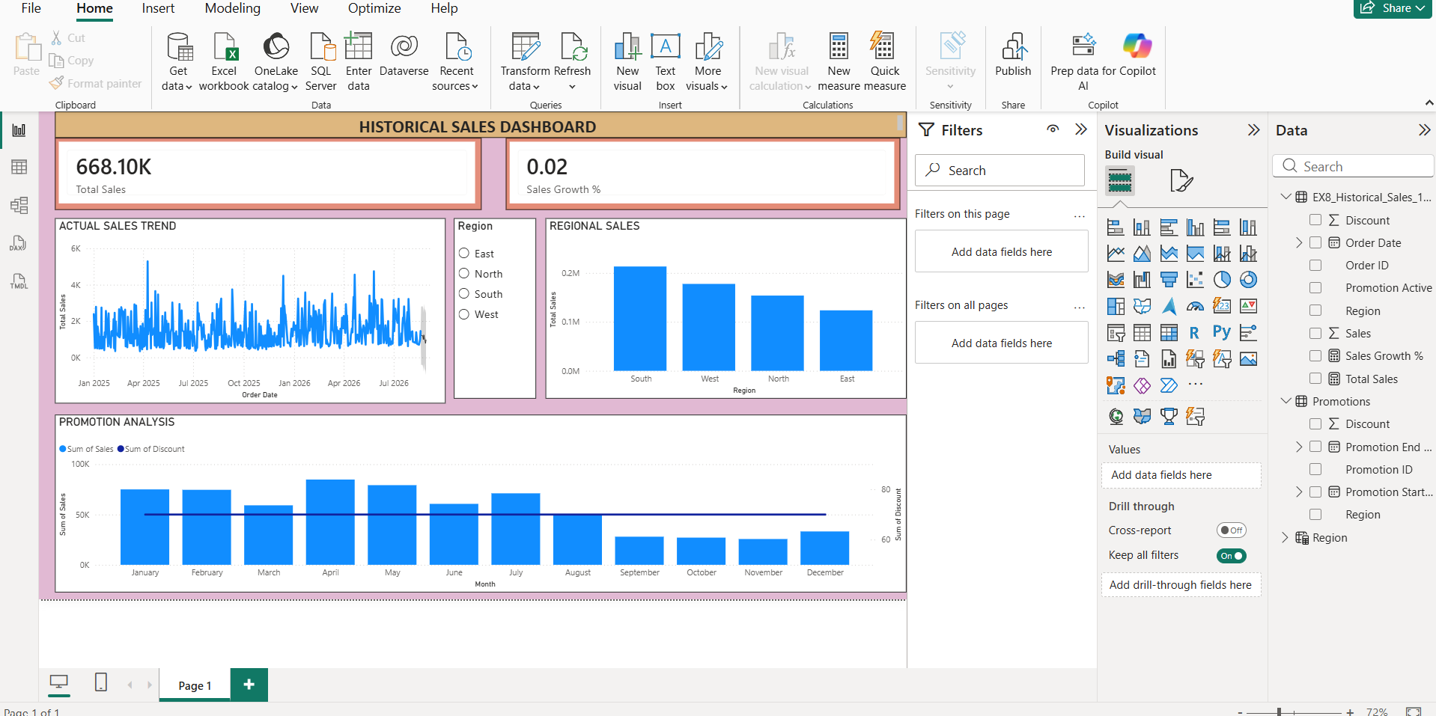
TABLEAU DASHBOARD :
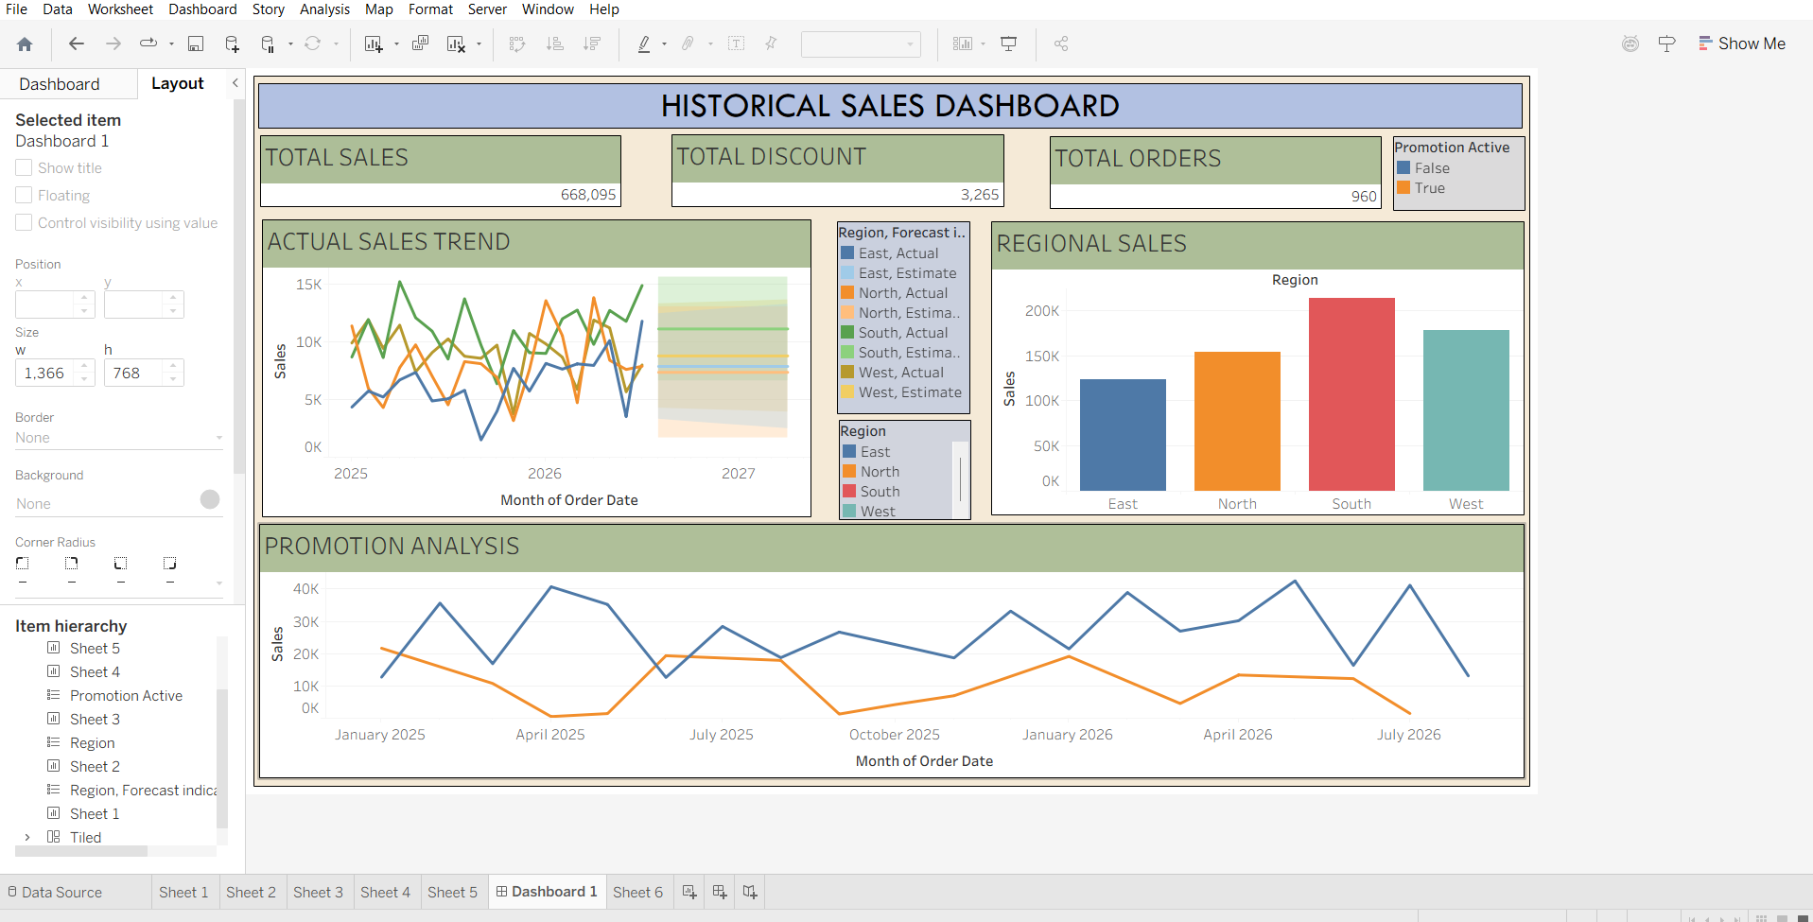
POST-LAB QUESTIONS
1. How did forecasting help in predicting future sales trends for business planning? Forecasting provided clear projections of expected revenue growth and regional sales performance based on past order history. Visualizing prediction intervals and seasonal peaks allows management to optimize inventory and budget allocations in advance. The visual metrics helped identify top-performing regions versus areas falling short of growth targets. Predicting future sales transformed historical data into actionable insights for proactive corporate decision-making.
2. What forecasting method did you use, and why was it suitable for the dataset? Exponential Smoothing (ETS) was used because it effectively models underlying level, trend, and seasonal components over time. It was well-suited for this dataset as historical sales exhibited repeating annual fluctuations during promotion windows. The algorithm assigns higher weight to recent orders while maintaining long-term historical seasonality. This provided realistic confidence intervals and accurate future monthly sales estimates.
3. What challenges, if any, did you face regarding missing data or irregular time intervals? Merging sales tables with active promotion periods created irregular date gaps and mismatched time formats. Aggregating transaction data into continuous monthly intervals was necessary to restore uninterrupted time-series tracking. Unlinked regional values across independent datasets initially caused unmapped fields before relationships were set. Cleaning empty order dates and switching X-axis settings to continuous restored accurate forecast visualizations.
4. How can predictive analytics influence decision-making in a retail environment? Predictive analytics helps retailers anticipate product demand, optimize inventory replenishment, and prevent stockouts. It assists in scheduling targeted promotional campaigns during regions and months with high projected customer response. Dynamic pricing and discount strategies can be evaluated by simulating anticipated changes in consumer spending. Overall, it reduces holding costs, maximizes profit margins, and streamlines supply chain operations.
5. What additional data could be integrated to improve forecast accuracy? Integrating macroeconomic indicators like inflation rates and consumer price indices would account for market purchasing power. Adding competitor pricing and external promotional activity would provide critical context regarding market share dynamics. Including regional weather patterns, localized holiday calendars, and marketing ad spend would refine demand spikes. Combining these external variables with internal sales records significantly reduces forecast error margins.

RESULT:
The historical sales and promotions datasets were successfully cleaned, integrated, and modeled in Tableau and Power BI. Forecasting techniques provided predicted sales trends, growth percentages, and region-wise performance expectations. The resulting dashboards allowed managers to visualize actual vs. forecasted sales, enabling better planning and datadriven decision-making.

ASSESSMENT

Description |  | Max Marks | Marks Awarded
Pre Lab Exercise |  | 5
In Lab Exercise |  | 10
Post Lab Exercise |  | 5
Viva |  | 10
 | Total | 30
 | Faculty Signature

